

High-Level Summary

GoodSecurity was tasked with performing an internal penetration test on GoodCorp’s CEO, Hans Gruber. An internal penetration test is a dedicated attack against internally connected systems. The focus of this test is to perform attacks, similar to those of a hacker and attempt to infiltrate Hans’ computer and determine if it is at risk.
GoodSecurity’s overall objective was to exploit any vulnerable software and find the secret recipe file on Hans’ computer, while reporting the findings back to GoodCorp. This report discusses the results from the assessment.
During the investigation, GoodSecurity covered good security practices while aiming to determine the following:
- Determine if the systems were suitably configured in line with good security practice.
- Assess if communications within the system were suitably protected from interception and general intervention.
- Evaluate whether the system were suitably protected against unauthorized activity from unauthorized users.
- Identify the presence of any vulnerabilities in the system’s front end which can be exploited to provide unauthorized access to data stored in backed databases.
- Identify publicly exposed ports and services which have documented vulnerabilities that can be exploited to bypass existing defenses.
When performing the internal penetration test, there were serious problems were identified on Hans’ desktop. When performing the attacks, GoodSecurity was able to gain access to his machine and find the secret recipe file by exploiting two programs that had major vulnerabilities. The details of the attack can be found in the ‘Findings’ category.
GoodSecurity discovered a total of 3 vulnerabilities in the assigned environment, of which 1 is critical. The critical vulnerability allowed the download of Mr Gruber’s “user.secretfile.txt” as well as the “Drinks.recipe.txt,” both of which are sensitive.
GoodCorp should be strongly motivated to remediate the critical vulnerabilities within 15 days due to the high potential for exploit of these files and many others which could result in significant monetary impact.

Findings

Machine IP:
192.168.0.20
Hostname:
MSEDGEWIN10
Vulnerability Exploited: (Critical)
Icecast Header Overwrite
Vulnerability Explanation:
In summary, buffer overflow in Icecast 2.0.1 and earlier allows remote attackers to execute arbitrary code via an HTTP request with a large number of headers.
This module is a buffer overflow exploit in the header parsing of the icecast versions 2.0.1 and earlier. It sends 32 HTTP headers which cause a write one past the end of a pointer array. On win32, this happens to overwrite the saved instruction pointer, and on Linux, this seems to generally overwrite nothing crucial. This exploit uses ExitThread(), and will leave icecast thinking the thread is still in use, therefore the thread counter won't be decremented. This means for each time your payload exits, the counter will be left incremented, and eventually the threadpool limit will be maxed. So you can multihit, but only till you fill the threadpool.
In short, is possible to execute remote code simply using the normal HTTP request plus 31 headers followed by a shellcode that will be executed directly without the need of calling/jumping to registers or addresses or using other annoying techniques.

Severity:
The CVSS (Common Vulnerability Score System) for this is a 7.5 out of 10, which is a high level of severity. Remote access is granted without authentication needed over the network.

Proof of Concept:
A service and version scan using NMap was used to determine which services are up and running:
nmap -sV 192.168.0.20
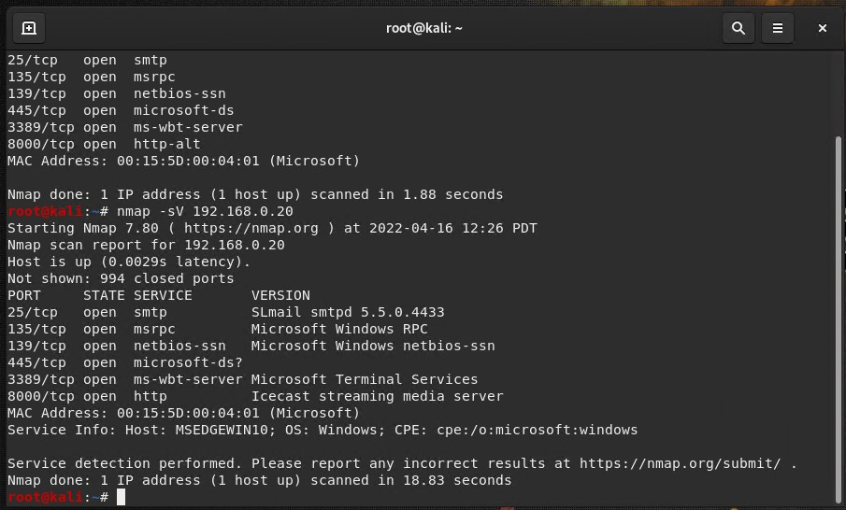
From the previous step, we see that the Icecast service is running on port 8000. We then search for exploits that are available for Icecast with the following command via SearchSploit:
searchsploit icecast
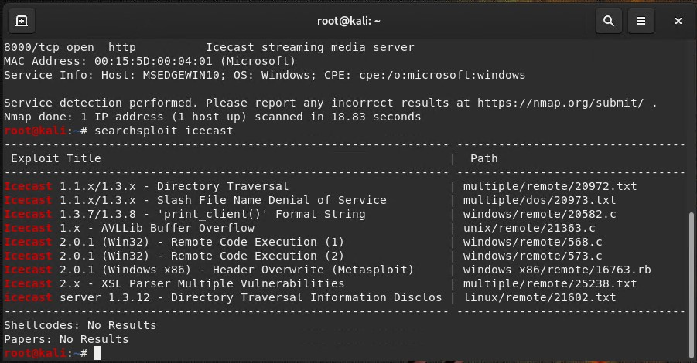
Now that we know which exploits are available to us for Icecast, we run Metasploit and search for exploits that we can use:
msfconsole
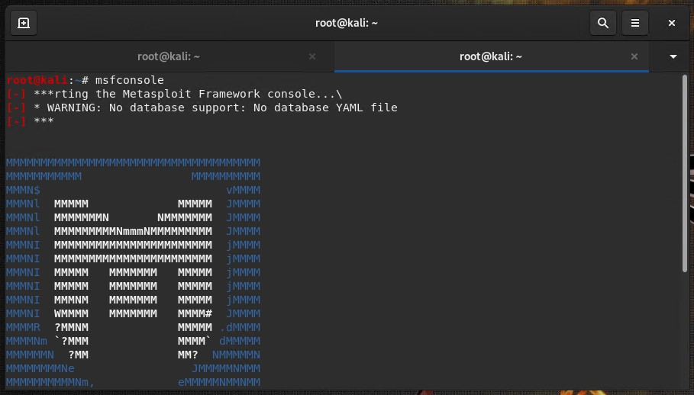
search icecast and use 0
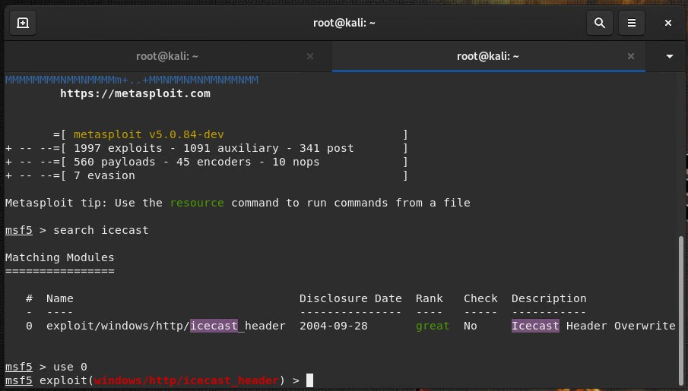
We set the RHOST (Remote Host/ target) for the exploit to be the IP address of Mr Gruber’s computer:
set rhosts 192.168.0.20
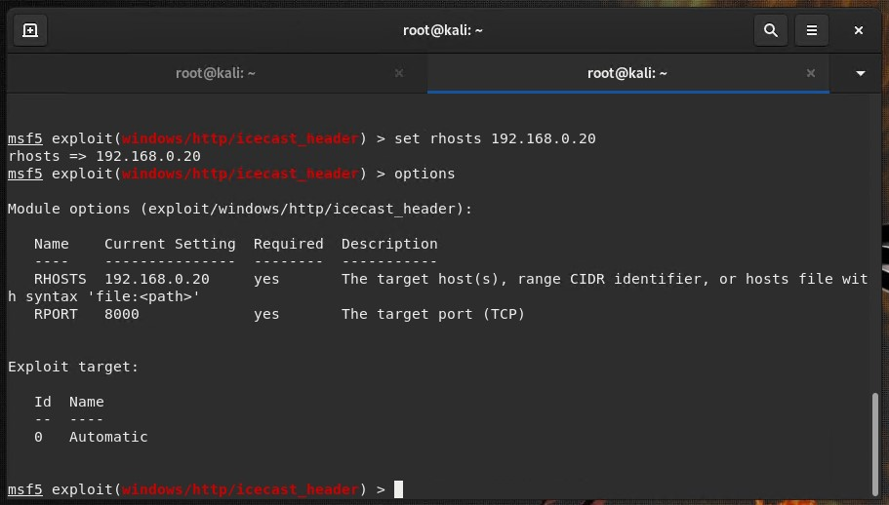
We then run the exploit against Mr. Gruber’s computer, and gain access with meterpreter. Through the meterpreter program, we begin a search for the target “secretfile” as instructed as one of the two files we are to find:
search -f *secretfile*.txt
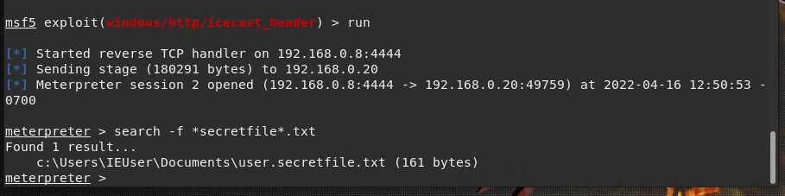
The file is successfully located inside the path C:\Users\IEUser\Documents\. The actual full file name is “user.secretfile.txt”

We continue with a search for the recipe file as well using the following command:
search -f *recipe*.txt
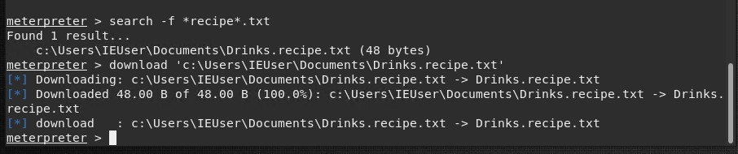
A “Drinks.recipe.txt” file was found in the system under the same directory path as the secretfile. We download a copy of the recipe file for good measure to demonstrate the dangers of this exploit and how information can indeed exfiltrate from the system with a simple download command:
download ‘c:\Users\IEUser\Documents\Drinks.recipe.txt’
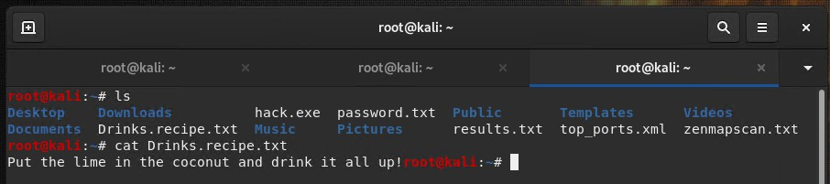
Inside the contents of the file, we find that the recipe for the drinks is possibly proprietary information.
Where there is 1 vulnerability, there may possibly be others that are worth exploring so that everything can be patched up together at the same time. We utilized our time in the system to search for these other possible vulnerabilities on the system with a suggester through Metasploit.
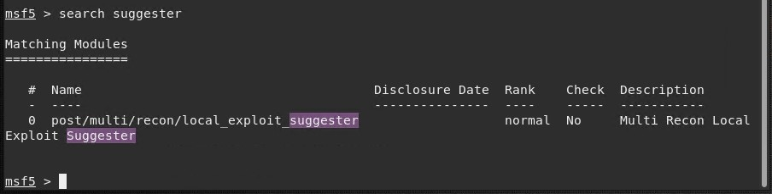

We set the target system to Mr. Gruber’s IP address and then begin our suggester program.
Run post/multi/recon/local_exploit_suggester
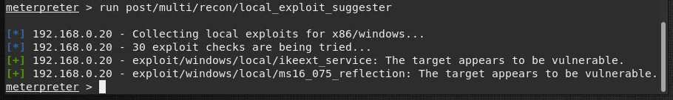
The results show those two additional, vulnerabilities mentioned in the summary. Information related to them are as follows:
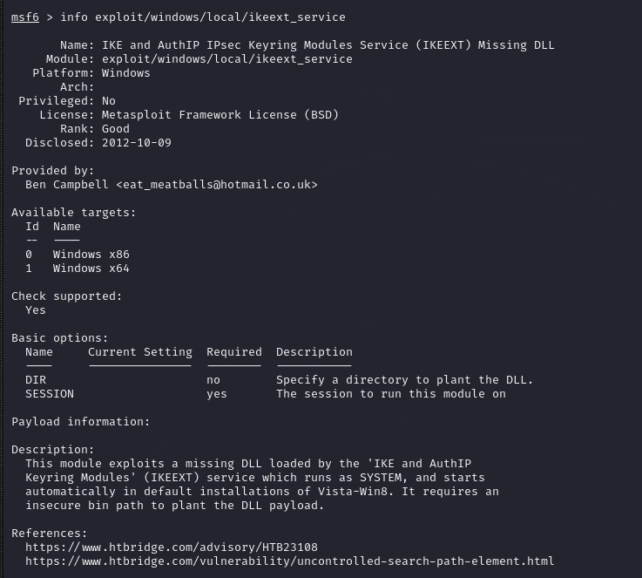
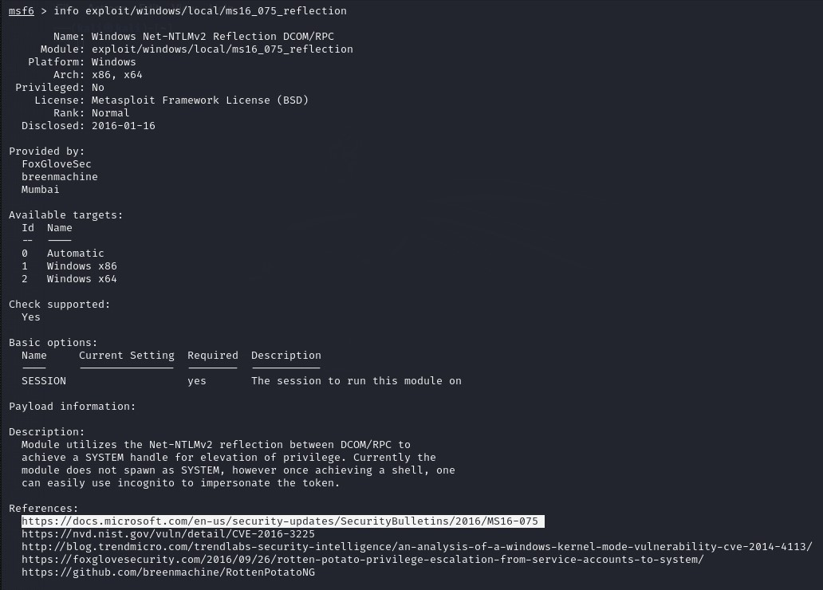

Vulnerability information for Icecast can be found in the following screenshot:
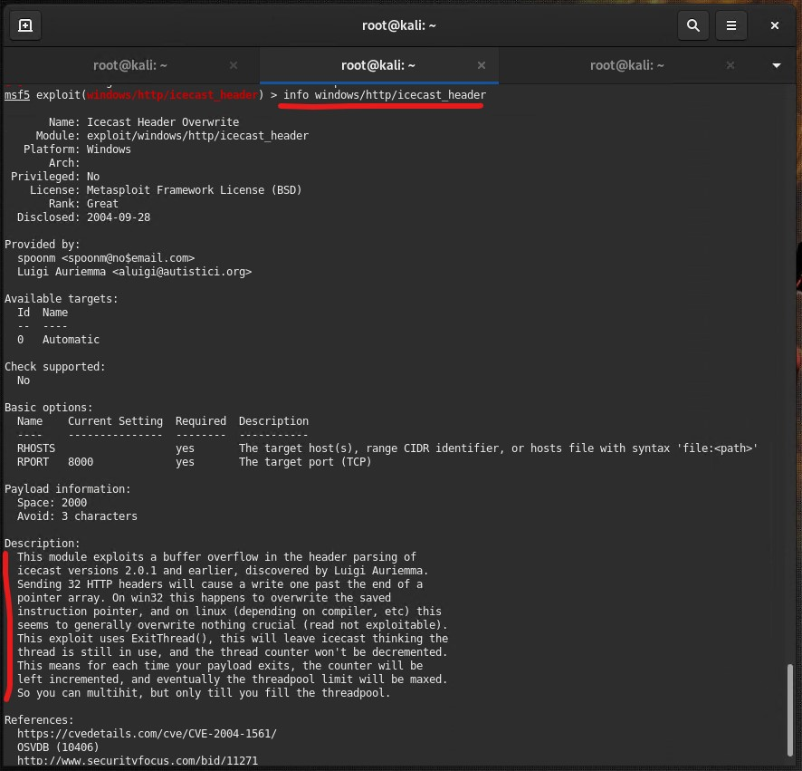
During the exploit of the Icecast application when we were able to open a meterpreter session, we were also able to see the logged user(s) on the computer with the following script:
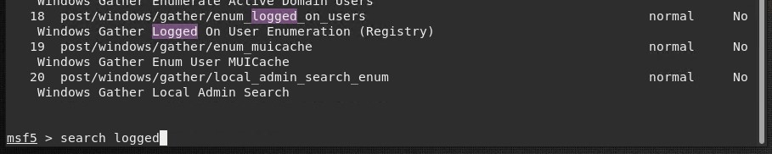
run post/windows/gather/enum_logged_on_users
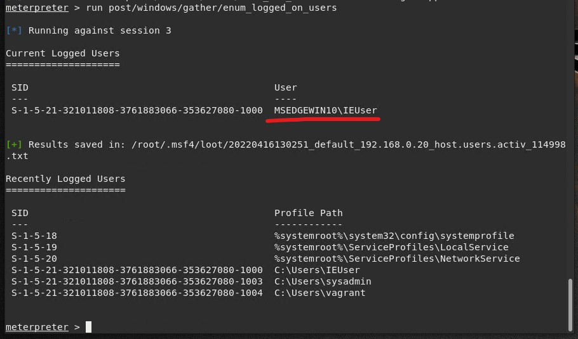
The command to open a shell on the system also worked:
shell
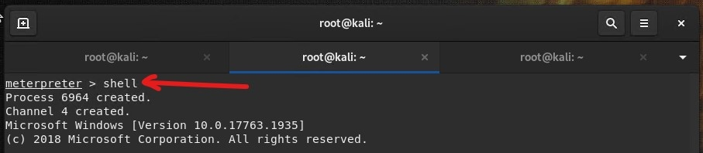

More information about Mr. Gruber’s system was found with shell access by using the Windows default commands to display everything for us:
systeminfo
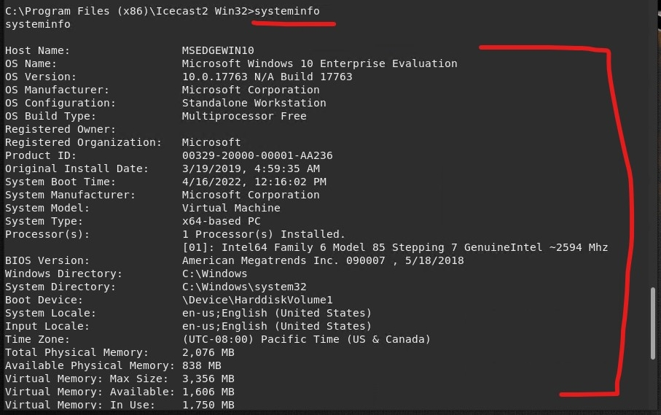
Vulnerability details of Icecast 2.0.1 and earlier. CVE-2004-1581.
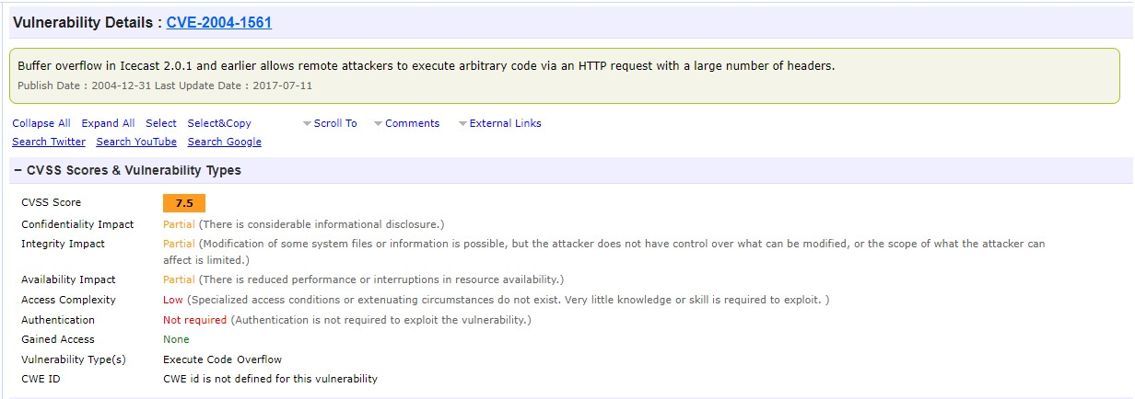

Recommendations

Icecast is an audio broadcast system that streams music in both mp3 and Obb Vorbis format. The solution to fix this problem is to upgrade to Icecast 2.0.2 or later. The most recent version at the time of this report is Icecast 2.4.4, which does not have any known vulnerabilities yet. Downloads of the newest version is available for both Linux/ Unit systems and Windows in the link below:
https://icecast.org/download/
By updating and upgrading the affected versions culpable to being attacked, you eliminate the problem of being exploited by the vulnerability that exists in the older versions. Since there have been several version upgrades since the original affected version installed, it is also safe to say that the issue will not be easily exploited by modified methods of the vulnerability.

Conclusions

Overall, the penetration tests performed on Mr. Gruber’s system revealed a limited number of vulnerabilities present during our review of everything. Only 1 critical issue was found, which can easily be patched by the IT department with a simple upgrade to the applications affected. Other minor findings discovered can also be explored further by the IT department or be followed up by other members of our team with follow up remediation or validation testing to ensure proper patching of those issues in the next 15-30 days.
We thank GoodCorp and appreciate the opportunity to assist in testing Mr. Gruber’s system with this proactive exercise to guarantee the safety of the company’s digital assets on sensitive target computers. This step, unquestionably saves the company from any loss of revenue and embarrassment which GoodSecurity hopes to be able to continually provide additional collaboration in the future with to further help GoodCorp Inc achieve good security practices.

